PREY
(original title: “Prooi”)
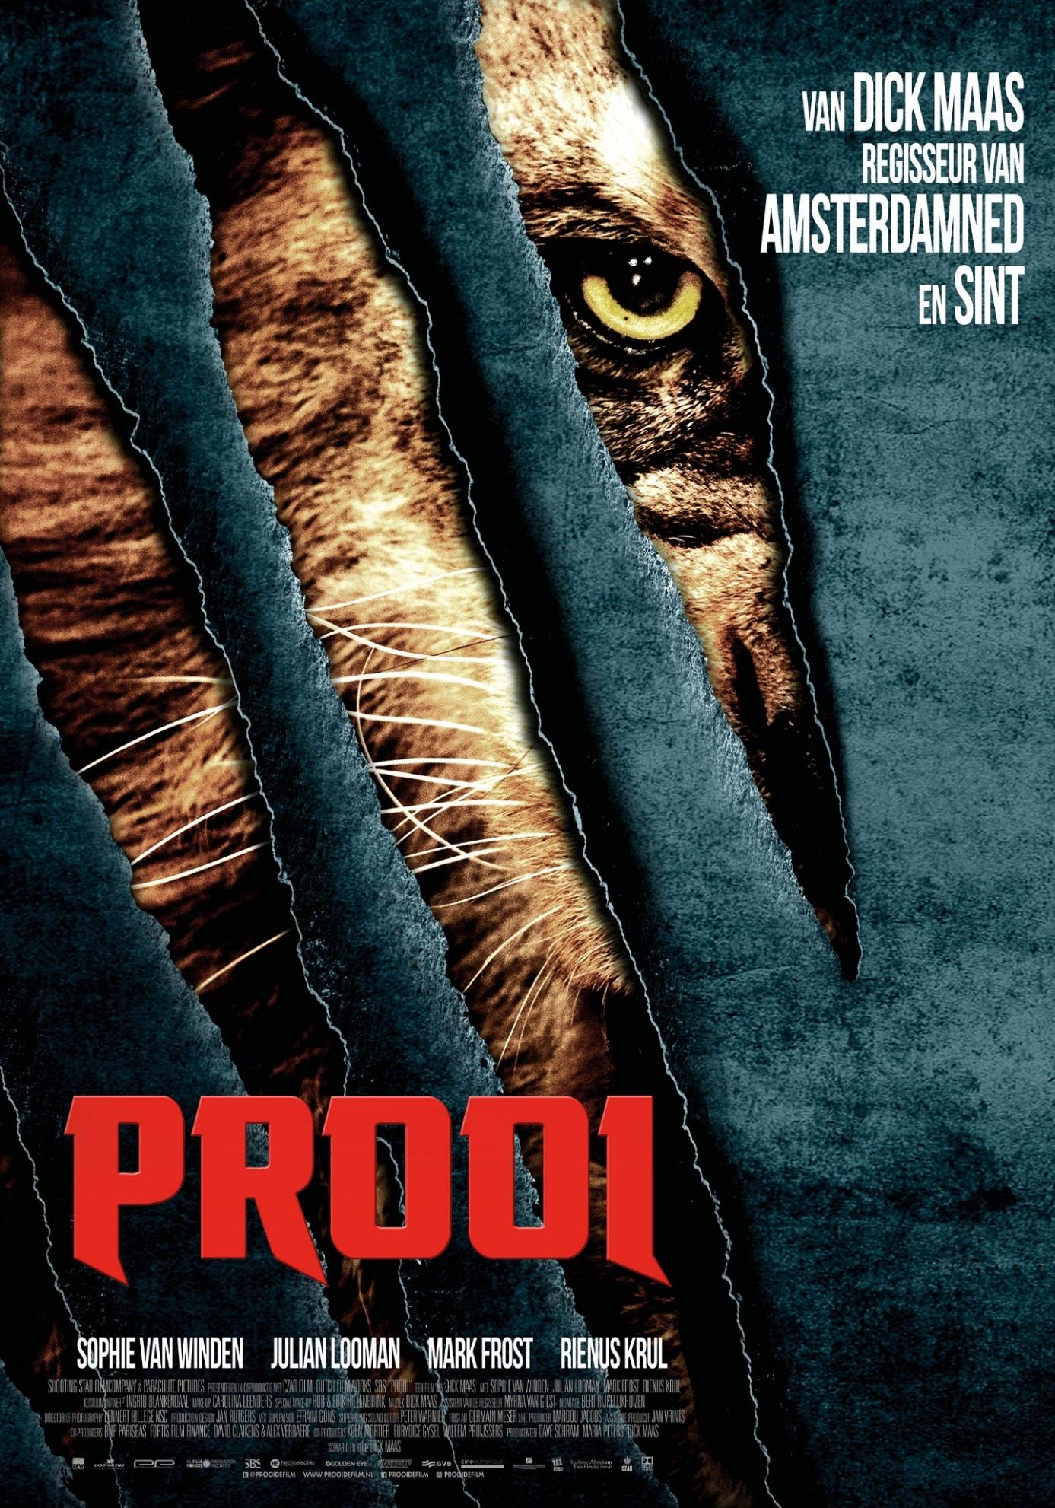

Short synopsis
After finding a gruesomely slaughtered farmer’s family just outside Amsterdam, the police calls Amsterdam Royal Zoo’s veterinarian Lizzy for help. She immediately sees what must have caused the bloody mutilations: an enormous, aggressive lion. Nobody believes her and it isn’t until after a bloodbath at the Vondelpark that the authorities agree with her plan to deploy the British hunter Jack. Lizzy’s boyfriend Dave has his doubts because of Lizzy and Jack’s past as lovers. But even he must admit that Jack is their best chance to prevent more bloodshed in the streets of Amsterdam. The hunt is on…

Full synopsis
When the police discover the bodies of a slaughtered family living on a farm just outside of Amsterdam, they are clueless as to what happened.
Lizzy, an attractive veterinarian working in the Amsterdam Zoo, confirms their suspicions; there must be a lion on the loose! And judging by the wounds of the mutilated victims, the lion must be big, strong and vicious!

Several more gruesome attacks follow and Lizzy is convinced a maneater is roaming the streets of Amsterdam but she has trouble convincing the authorities of the danger. When they finally set up a press conference to warn the public of the danger, their statement is met with disbelief. No one has seen the lion, and there is not much evidence of its existence. The public’s disbelief disappears when the lion goes on a murder spree in a streetcar full of people.
After a disastrous failed attempt by the nephew of the chief of police to hunt down and kill the lion, a friend of Lizzy’s, a famous English lion hunter, is flown in.
The police are stunned to see that the man has only one leg and is confined to a wheelchair. Slowly their worries disappear when the man seems to know what he is talking about and his powerful wheelchair, equipped with snowmobile tracks, makes him almost as fast as a speeding lion.
Still, the authorities are not convinced of the lion hunter’s skills. They send in an army squad, but their mission ends in more bloodshed – albeit not the lion’s.

Finally, the lion hunter gets permission to hunt down the lion in his own way. He succeeds in tracking down the lion to a University building and with Lizzy’s help he manages to kill the beast, losing his life in the process. When Lizzy accompanies her deceased friend in an ambulance to the hospital, the lion has one more surprise up his sleeve...

About the director:
Dick Maas is unequaled in the history of Dutch cinema. And we’re not talking about box office earnings. Since he had his first box office hit in 1983 with DE LIFT Dick has followed his own course, averse to trends, funds and critics. It earned him an international reputation of being a headstrong director.
Dick Maas (Heemstede, 1951) graduated from the Dutch Film Academy in 1977 with the short suicide comedy ADELBERT. It was the first in a row of short films that showed his morbid sense of humor. In 1981 he made the TV-film RIGOR MORTIS, in which Wim T. Schippers attempts to break the world record for spending the longest time buried alive, whilst his wife cheats on him.
Maas had his break-through in 1983 with his film DE LIFT (The Lift), the first successful Dutch horror movie. It earned him the Grand Prix at the Avoriaz film festival, but even more importantly, the low budget movie attracted 648.000 visitors. And just like his inspiration, John Carpenter, Maas composed the synthesizer score himself.
Dick Maas and producer Laurens Geels made the film FLODDER and started their own film studio, First Floor Features. After roughly 2.3 million visitors Holland had finally found a successor to Paul Verhoeven. His first two feature films were both awarded a Gouden Kalf (Golden Calf) at the Netherlands Film Festival and meanwhile his studio was producing Alex van Warmerdam’s directing debut ABEL, Golden Calf-winner LEVE DE KONINGIN (Long Live the Queen) by Esmé Lammers and Oscar-winner CHARACTER by Mike van Diem. FFF produced 65 episodes of the TV-series FLODDER, a number of which were written by Maas. Maas kept attracting audiences to his films: AMSTERDAMNED (1 million visitors), FLODDER 2 (1,5 million) and FLODDER 3 (400.000).
In 1993 Dick directed an episode of THE YOUNG INDIANA JONES CHRONICLES, produced by George Lucas. Two of his international productions were less successful, DO NOT DISTURB with William Hurt and a remake of DE LIFT, DOWN (2001) with leading actress Naomi Watts. First Floor Features was forced to shut its doors in 2004 but Maas refused to throw in the towel. With a new producer, Tom de Mol, he scored two box office hits with MOORDWIJVEN (Murdering Babes) and SINT (Saint Nick). The third collaboration with De Mol showed a different side of Maas. QUIZ (2012) was a modest character study with two well worked out characters, made memorable by Pierre Bokma and Barry Atsma.

Review “Brussels International Festival of Fantastic Film”
PREY
A family is found slaughtered on a farm nearby Amsterdam. The police don’t find any clues as to who or what did this, but Lizzie, who’s a vet at the Amsterdam zoo, recognizes the mutilations from her time in Africa and suspects this is the work of one very big lion. At first her claims are not taken seriously until a bunch of new victims are ripped apart. Our feline has chosen Amsterdam as its hunting ground. The authorities bring in the English wheelchair-bound big game hunter Jack. Lizzie has to collaborate with him and at the same time keep her boyfriend Dave in check, who’s a reporter with a sensationalist TV-channel. And the lion is hungry, really really hungry!

Dick Maas is back and he’s in terrific shape. The Dutch BIFFF regular has given us genre gems such as The Lift, Amsterdamned and Sint and had the great idea to release a lion on the Amsterdam streets. Prey is a feast for hemoglobin lovers. Head are severed, entrails pulled out and limbs are flying all over the place. Maas spares nothing and no-one and shows no mercy. The plot doesn’t take itself too seriously and contains many jokes, which allows you to relax a bit in between all the horror.

KEY CREDITS

Director: Dick Maas
Script: Dick Maas
Producers: Dave Schram, Maria Peters, Dick Maas
Director of Photography: Lennert Hillege

Cast:
Lizzy - Sophie van Winden
Dave- Julian Looman
Jack – Mark Frost
Brinkers- Rinus Krul
Amateur Hunter - Victor Löw

