T E R R O R

O N T H E

P R A I R I E

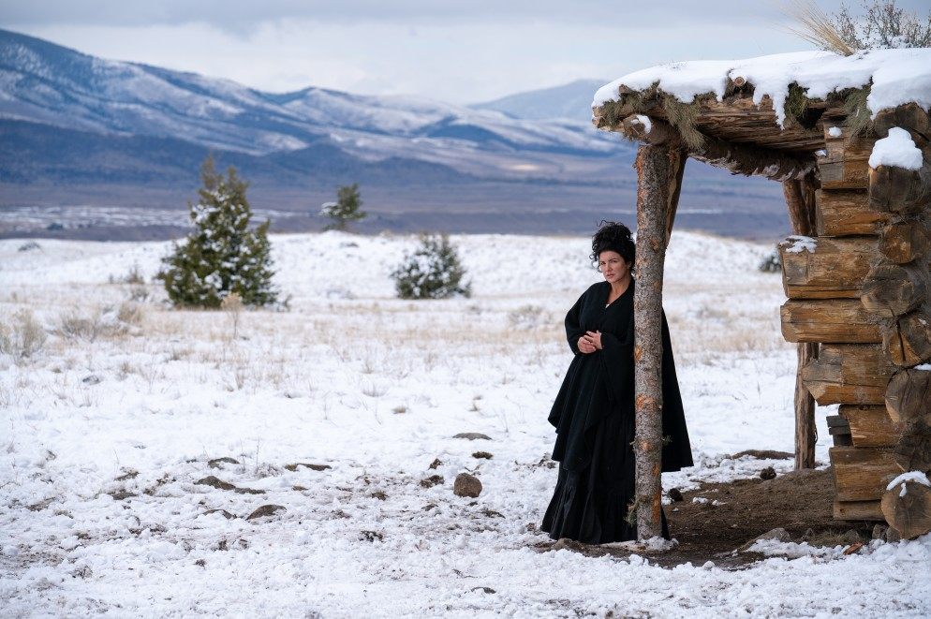

A
MICHAEL POLISH
Picture

107 mins
USA 2022

Synopsis
During the winter of 1875, a frontier woman must protect herself and her kids against a ruthless gang of outlaws hellbent on revenge.

About the Production
TERROR ON THE PRAIRIE is the second original movie production for The Daily Wire. The movie, produced by Dallas Sonnier, Amanda Presmyk and Jeremy Boreing, was written by Josiah Nelson and directed by Michael Polish. This is the first-ever produced screenplay for writer Josiah Nelson, and the first project for actress Gina Carano (who also served as a producer) following her firing from Disney’s THE MANDALORIAN in February of 2021.

TERROR was filmed on location in Paradise Valley, Montana in the foothills of the Montana Absarokas. The homestead set featured in the movie is entirely practical, built at the Yellowstone Film Ranch where the company filmed over four weeks during October-November, 2021. All the movie’s effects – from gunfire to scalping to burning down the cabin – are practical.

Director’s Commentary
Dallas Sonnier (Producer) and I have known each other for many years. When he approached me with TERROR ON THE PRAIRIE, I immediately felt intrigued by the genre. After reading the script, I knew it was something I wanted to be involved in. I live in Montana and I grew up around cattle ranches. I’m very familiar with western landscapes and terrain. My family has roots in Montana as well, so any opportunity to use this vast landscape as a backdrop speaks to my heart.

It was more typical to see a Western when I was growing up than it is today, so I’m always drawn to the opportunity to explore this genre as a Director. As for influences, the two people who inspired me for this film are Michael Cimino and Sergio Leone. Cimino because of his obsession with Montana and Sergio’s scope on Westerns. My films have always had photography at the forefront and TERROR ON THE PRAIRIE created a wonderful juxtaposition of magical landscapes with villainous characters.

Westerns are typically written for a male lead, so it’s uncommon for a female to be in this role. Hattie’s character did such a beautiful job of holding up both masculine and feminine energies amongst a male dominated cast. Audiences will be drawn to Hattie’s warmth as a mother and be blown away by her strength as a protector of her home. Her character represents the modern woman.

Dallas is really the genius behind the cast and his relationships with every cast member allowed us to create really authentic characters. The role of Hattie was very physical, and Gina’s athletic abilities allowed for her to fully embody the character. Beyond that, Gina did an incredible job exploring the emotions of being a mother, protecting her young, and stepping into her husband’s role in his absence. And Cowboy Cerrone... he really lives up to his name. His background as a fighter and undeniable drive allowed him to dive into his character fully.

There were many favorite memories on this production, but nothing compared to working with Heath Freeman. He took his work very seriously and treated it with so much respect. His ability to show up and play full out is what I admired most in him. He also insisted he do his own stunts, including laying in a burning building in one of our final scenes. I told him many times, he did not have to do his own stunts, but he insisted... that’s just who he was.

My experience working on TERROR ON THE PRAIRIE was unique to other films I have done because it was shot during a time when the entire world was shut down and very few productions were happening. The crew that was assembled brought so much drive and passion to set every single day. They chose to be there even with the challenging elements that Montana brings in the fall. You create a really special movie under those circumstances.

At the end of the day, the story is about commitment to marriage and how family is the most important thing.

– Michael Polish (May 2022)

About the Filmmakers

Michael Polish – Director

Michael Polish is one of today's most critically acclaimed directors. Michael recently wrapped shooting the feature film TERROR ON THE PRAIRIE. Additionally, Michael completed a full season of BRING ON THE DANCING HORSES. He wrote, produced and directed all ten episodes with Kate Bosworth starring. The series premiered at Sundance 2022.

On the feature side, Michael directed FORCE OF NATURE starring Mel Gibson, Emile Hirsch and Kate Bosworth. Michael also wrote, produced and directed NONA, which follows a young girl's journey from Honduras to Guatemala, across Mexico, and ultimately through the borders to America. NONA premiered at the Sun Valley Film Festival and won Sun Valley's "1 in a Million Award" for best narrative, opening Night at the Richmond International Film Festival and The Seattle International Film Festival's "centerpiece". Polish's first feature film TWIN FALLS IDAHO premiered at the Sundance Film Festival to rave reviews and was hailed by respected critic Roger Ebert as "one of the best films of 1999."

Some of his other credits include THE ASTRONAUT FARMER, NORTHFORK, and BIG SUR an adaptation of the Jack Kerouac novel. This has film garnered much critical acclaim and The New York Times gave a major stamp of approval, "Big Sur Cracks The Code" - how to adapt a novel to screen. Michael also directed a documentary LITTLE BROTHER OF WAR, Michael is the first filmmaker to gain access to the game of Stickball and was given permission by the Choctaw People to explore the Native American culture.

Josiah Nelson – Writer

Hailing from the great American plains, Josiah Nelson is a graduate of the MFA in Screenwriting program at Pepperdine University. After studying under such industry veterans as Randall Wallace (BRAVEHEART) and Sheryl J. Anderson (SWEET MAGNOLIAS), he quickly began developing projects at production companies like Alcon Entertainment, Wigram Productions, and MadRiver Pictures. Relocating to Austin, Texas, he continues to write his characteristic brand of vivid, character-driven action.

TERROR ON THE PRAIRIE marks a reunion between Josiah Nelson and Dallas Sonnier, whose Caliber Media first the young writer straight out of film school. The story is also deeply personal, as it was inspired by oral stories and family history of Josiah's great-great-grandparents who once homesteaded on the turbulent frontier in the mid 1800s. The script was a quarterfinalist in the Screencraft and Scriptapalooza screenplay competitions, as well as reaching the second round of the Austin Film Festival.

Dallas Sonnier – Producer

Dallas Sonnier started attending film school at the University of Southern California while still a student at Highland Park High School in Dallas, TX. Later as an undergrad, Sonnier helped establish and became the first student to graduate from a joint venture between the film and business schools that allowed students to major in the Business of Cinema, a program that focuses on the production and representation areas of the entertainment industry. The program continues today as the Business of Cinematic Arts, and Sonnier continues to serve as a BCA Alumni board member.

Upon graduating from USC, Sonnier started immediately with United Talent Agency, one of the top entertainment agencies in the business, then and now. With grit and determination, he soaked up every bit of education as an assistant before moving on to represent actors, writers, and directors as a manager at The Schiff Company. Sonnier worked closely with Schiff clients Wesley Snipes, Justin Timberlake and Jeff Bridges, while also signing and representing breakout talents such as Greta Gerwig, Leslye Headland, Shawn Christensen, and Jenny
Lumet. He also helped package several client projects, including Alex Timbers’s Mozart in the Jungle (Amazon) and Jessica Goldberg’s The Path (Hulu). Sonnier went on to co-found Caliber Media with Jack Heller and together they built a series of action movies starring WWE legend Stone Cold Steve Austin that also starred Steven Seagal, Michael Jai White, and Dolph Lundgren.

Returning to his home state of Texas in 2015 after more than a decade of working in Hollywood, Sonnier established a reputation for unexpected and singular movies, including the ultra-violent Western BONE TOMAHAWK (starring Kurt Russel & Richard Jenkins), which marked the directorial debut of screenwriter S. Craig Zahler. BONE TOMAHAWK premiered as the closing night movie at Fantastic Fest in Austin and ushered in the Age of Zahler, an auteur whose name is now synonymous with his gritty, lawless action movies like BRAWL IN CELL BLOCK 99 (starring Vince Vaughn & Don Johnson) and DRAGGED ACROSS CONCRETE (starring Mel Gibson & Tory Kittles) that Sonnier’s collaboration allowed him the freedom to create.

In 2016, Sonnier announced the creation of his Dallas-based company CINESTATE, which produced numerous feature-length movies in its early years, including THE STANDOFF AT SPARROW CREEK (starring James Badge Dale) and SOUTH OF HEAVEN (starring Jason Sudeikis & Evangeline Lilly).

Sonnier also acquired and resurrected the iconic horror magazine FANGORIA, and expanded it into a full-scale entertainment brand, even producing horror movies such as PUPPET MASTER: THE LITTLEST REICH (starring Thomas Lennon & Barbara Crampton), SATANIC PANIC (starring Rebecca Romijn), VFW (starring Stephen Lang, William Sadler & Fred Williamson), CASTLE FREAK (the directorial debut of SFX wizard Tate Steinsiek), and THE SEVENTH DAY (starring Vadhir Derbez & Guy Pearce).

In the midst of a global pandemic & deeply polarized body politic, Sonnier’s firebrand of moviemaking was attacked by the outrage mob, so he decided to sell FANGORIA and refocus his producing efforts on making movies that were more personal to his ethos. Sonnier launched his new label BONFIRE LEGEND and set out to help build a movie business for The Daily Wire, the conservative media group owned by Ben Shapiro & Jeremy Boreing. The first Daily Wire / Bonfire Legend release was RUN HIDE FIGHT (starring Isabel May & Thomas Jane) in 2021, followed by SHUT IN (starring Rainey Qualley & Vincent Gallo) in February 2022, and TERROR ON THE PRAIRIE (starring Gina Carano & Nick Searcy) soon after. Sonnier remains one of the most prolific, provocative movie producers of his generation.

Amanda Presmyk – Producer

Amanda Presmyk is a film producer from Texas. She has produced eleven feature films in five years, including Kyle Rankin’s RUN HIDE FIGHT (Thomas Jane, Isabel May), which world premiered at the 2020 Venice Film Festival and was released by The Daily Wire in January 2021; Henry Dunham’s THE STANDOFF AT SPARROW CREEK (James Badge Dale), which debuted at the 2018 Toronto International Film Festival to critical acclaim; and S. Craig Zahler’s DRAGGED ACROSS CONCRETE (Mel Gibson, Vince Vaughn), which world premiered at the 2018 Venice Film Festival.

Most recently, SHUT IN, directed by DJ Caruso (DISTURBIA) premiered in February 2022. TERROR ON THE PRAIRIE, the anticipated action- western directed by Michael Polish (NORTHFORK, BIG SUR) and starring Gina Carano (THE MANDALORIAN) is set to be released in June 2022. Other recently released titles include Netflix’s THE SEVENTH DAY (Guy Pearce) and Universal’s SOUTH OF HEAVEN (Jason Sudeikis, Evangeline Lilly).

Horror-actioner VFW (Stephen Lang), horror-comedy SATANIC PANIC (Rebecca Romijn, Jerry O’Connell), a reimagining of the horror classic CASTLE FREAK, and PUPPET MASTER: THE LITTLEST REICH (Tom Lennon, Udo Kier), a franchise reboot penned by S. Craig Zahler, are all titles produced by Presmyk and released under the FANGORIA banner.

Presmyk got her start in the industry producing commercials, then serving as the assistant to a longtime television producer on television series like QUEEN OF THE SOUTH. She served as a key member of the nationally recognized Oak Cliff Film Festival for six years, including heading operations for the festival and holding a position on the board of the Oak Cliff Film Society. Presmyk graduated from Southern

Methodist University in Dallas, Texas, where she double-majored in Film and Media Arts and Convergence Journalism. She currently resides in Atlanta, Georgia with her husband and their dog, Charlie.

Jeremy Boreing – Producer

Jeremy Boreing is the co-founder and co-CEO of Bentkey Ventures LLC, home of The Daily Wire, a conservative news and commentary company with more than 170,000,000 monthly page views, and The Ben Shapiro Show, the largest conservative podcast in the country with over 1.4 million listeners each day. The Daily Wire, now in its 5th year continues to break records earning the #1 spot on Newswhip’s “Top Web Publishers On Facebook” list for July 2020-April 2021.

Boreing also hosts the popular podcast Backstage, where he is known affectionately, or sardonically, as the god-king. The show boasts an audience of a million downloads per episode and features other talent from The Daily Wire.

Boreing is a filmmaker with writing and producing credits on several feature films, most notably The Arroyo, which he also directed, a modern western set against the lawlessness of America’s southern border.

Steeven Petitteville – Director of Photography

Steeven Petitteville is an award winning cinematographer working worldwide. Steeven was born in Paris, France, and got an early start in photography printing black and white film when he was just 13. Following graduation from film school in Paris, Steeven served as a 1st Assistant Camera for cinematographers like Bruno Delbonnel, Rodrigo Prieto, and Lance Acord and worked as camera operator and 2nd Unit DP on international projects.

Steeven’s career as a cinematographer began with commercials and music videos, which soon lead to shooting features for directors Phil Joanou, Logan Kibens, and Maurice Barthelemy, among others.

He often collaborates with renowned artists, writers, and choreographers (including Bret Easton Ellis, Benjamin Millepied, William Forsythe, and Youssef Nabil) on their directorial debuts and art pieces. His cinematography has been awarded multiple times (MOTION SICKNESS, Best Cinematography & Best Art in Film at Belfast Film Festival; LET'S DREAM OF A NEW WORLD, Best Cinematography at US International Film & Video Festival) and his artistic collaborations have been exhibited in Berlin, Prague, and Belfast and screened at Paris Opéra and Gagossian Galleries.

Steeven is always willing to help the story with innovative visuals.

Allyson Adams – Costume Designer

Award-winning costume designer, Allyson Adams, was born in Hollywood to actor parents Carol Nugent and Academy Award nominated actor, Nick Adams, known for the western television series The Rebel. Ms. Adams grew up on film sets and westerns are in her blood.

TERROR ON THE PRAIRIE is Ms. Adams third western, with prior Costume Design credits for CHIEF TENDOY and FOUR WINDS. FOUR WINDS won Best Costume Design at the Los Angeles Movie Awards.

Ms. Adams lives in historic Virginia City, Montana where she owns The Montana Picture Gallery (est. 1864) and has a period costume shop.

Paul Buhl – Editor

After eight years of editing features in his hometown of Boston, MA, Paul moved to Los Angeles in 2010, landing a steady gig at a VFX house in Santa Monica running their feature film development department. After a few years of cutting pitch pieces for major LA players like Ridley Scott, Brett Ratner and MGM, and features with Wesley Snipes, Rob Schneider and Scott Eastwood, Paul met indie film auteure Michael Polish and began to form a solid director / editor relationship.

Working with Michael on a feature starring Mel Gibson, Emile Hirsch and Kate Bosworth called FORCE OF NATURE, a documentary on Native

American stickball, and a 10-episode Series called BRING ON THE DANCING HORSES, led to Paul coming on to edit TERROR ON THE PRAIRIE.

Buz Wallick – Co-Producer

Buz Wallick was born and raised in the California town of Paradise, where he was weaned on a diet of John Carpenter and Stephen King. Buz has a unique experience of being a self-taught artist who has worked on over 100 projects across the country in the last 15 years. Buz uses his broad understanding of film production to do what he loves: create stories through the lens of the camera.
.

Travis Mills – Co-Producer

Travis Mills was born in Quito, Ecuador. He spent the majority of his early life abroad in Europe and Africa before returning to the United States. In the U.S., he settled in Arizona where he co-founded Running Wild Films in 2010 with playwright Gus Edwards. Since then, they have produced 25 feature films and more than 100 short film projects. In 2020, he completed production on his most ambitious project yet: 12 feature-length Western films in 12 Months. The next year, he published a book which is available on Amazon about this experience titled The Making of 12 Westerns: Or How I Made a Dozen Movies During a Global Pandemic and Survived. During 2021, Mills also collaborated with producer Dallas Sonnier on the Gina Carano-starring Western, TERROR ON THE PRAIRIE.

About the Cast

Gina Carano – “Hattie McAllister” / Producer

From pioneering women's MMA to blazing a trail in movies, GINA CARANO is one of Hollywood's most unique rising stars. Carano began her training with Muay Thai to competitive MMA, where she competed in Strikeforce and EliteXC. Her popularity led to her being called the "Face of Women's MMA" and she was the fastest-rising search on Google and third-most-searched person on Yahoo and ranked 5th on a list of
the "Top 10 Influential Women" of 2008. In August 2009, Carano fought Cris Cyborg in Strikeforce: Carano vs. Cyborg, the first time two women headlined a major MMA event and at the time was the highest rated fight in Showtime history. Carano compiled a competitive record of 12-1- 1 in Muay Thai and a 7-1 in women's MMA.

Outside the ring, Carano served as a mentor to aspiring fighters in the 2007 Oxygen reality series Fight Girls and performed as 'Crush' in the revamped television series American Gladiators before her breakout performance in Steven Soderbergh's film HAYWIRE, holding her own against the likes of Michael Douglas, Michael Fassbender, Channing Tatum, Bill Paxton and Antonio Banderas. Gina's authenticity to making the Action look real earned her performance a Critics Choice Award Nomination for Best Actress in an action film. Hot on the heels came a role in the worldwide hit FAST AND FURIOUS 6 for Universal Pictures opposite Dwayne Johnson furthering her appeal as an Action Star. Next up, she co-starred alongside Robert DeNiro, Jeffrey Dean Morgan and Dave Bautista in Lionsgate's film HEIST followed by the role of
'Angel Dust' in the smash hit MARVEL/FOX film DEADPOOL opposite Ryan Reynolds based on the popular comic book. The film grossed over
$870 Million dollars at the Box Office. After starring in the independent films DAUGHTER OF THE WOLF opposite Richard Dreyfuss and the dark comedy MADNESS IN THE METHOD with Jason Mewes and Kevin Smith, Gina secured a lead role in Jon Favreau's highly reviewed Star Wars TV show THE MANDALORIAN for Disney +. Gina played 'Cara Dune', a former Rebel Shock Trooper and worked with directors such as Taika Waititi, Deborah Chow and Bryce Dallas Howard on the series.

Carano was born in Dallas, Texas, the daughter of Dana Joy (née Cason) and professional football player Glenn Carano who played for the Dallas Cowboys and was the backup quarterback to Roger Staubach. She has two sisters, one older and one younger.

Cowboy Cerrone – “Jeb McAllister”

Donald Cerrone, known professionally by his nickname “Cowboy”, is an American mixed martial artist and former professional kickboxer. He currently fights in the Welterweight division for the Ultimate Fighting Championship (UFC). No fighter in UFC history has more wins than Cowboy, who can claim an absurd 23 wins, as well as the most finishes and most knockdowns in the history of the sport.

Cerrone has had a handful of roles in film and television since 2017, including the 2020 Netflix film SPENSER CONFIDENTIAL. Cerrone also made an appearance alongside Paul Felder and Dana White in season 12 of It’s Always Sunny in Philadelphia and in the neo-Western THE HARDER THEY FALL (Netflix, 2021). The role of “Jeb” in TERROR ON THE PRAIRIE is his first starring role.

Nick Searcy – “Captain Miller”

A consistent presence in film and television for over 30 years, Nick Searcy has starred in independent films as well as studio blockbusters, including CAST AWAY, THE LAST SONG, THE UGLY TRUTH, THE DEAD GIRL, RUNAWAY JURY, NELL, HEAD OF STATE, GREATER, MONEYBALL,
and FRIED GREEN TOMATOES, among others.

In 2018, he appeared in two Academy Award Best Picture nominees, 3 BILLBOARDS OUTSIDE EBBING, MISSOURI, and the winner, THE SHAPE OF WATER. In 2019 he was seen in the feature film THE BEST OF ENEMIES as well as the acclaimed NatGeo miniseries THE HOT ZONE, and the Spectrum miniseries MANHUNT DEADLY GAMES.

He produced his first documentary in 2020, AMERICA AMERICA GOD SHED HIS GRACE ON THEE, a study of the relationship between God and America, and his second in 2021, CAPITOL PUNISHMENT, a movie about the people who went to Washington, along with Nick himself, on January 6th.

After completing a six-year run as Chief Deputy Art Mullen on the popular FX series JUSTIFIED, he appeared as Deke Simmons in Hulu’s 11/22/63, and has also been a series regular on UPN’s 7 Days, CBS’s American Gothic, HBO’s From The Earth To The Moon, ABC’s Rodney, and CW’s Easy Money, and has guest starred on countless shows including 9-1-1, Chicago Med, Hawaii 5-0, Mom, Hot in Cleveland, Intelligence, Archer, The Mentalist, Lie To Me, Without a Trace, The West Wing, CSI, and NCIS.

As a director, Nick’s second film, GOSNELL, released in 700 theatres nationwide on October 12, 2018, was the number 1 independent film in the country for its first week and cracked the top ten for its opening weekend. His first film, CAROLINA LOW, is currently available on Amazon Prime. And of course, Nick is the biggest Hollywood star ever to guest-host the Rush Limbaugh radio show, which he did on Dec. 27, 2017.
In 2022, in addition to TERROR ON THE PRAIRIE, he will appear in REAGAN, starring Dennis Quaid, and THE OLD WAY, starring Nicolas Cage.

Tyler Fischer – “Long Hair”

Tyler is an actor, stand-up comedian and viral content creator based in NYC. He has performed stand-up on America's Got Talent, been a guest star on NBC's Chicago Med, TV Land's YOUNGER, and STARTUP on Netflix. Tyler is known for his viral content with over 50 million views on his prank, sketch and Celebrity impression videos. He was named “The Best New Impressionist” by the New York Times and “NY’s Funniest Comedian” at the NY Comedy Festival. He has been on Last Week Tonight with John Oliver and The Late Show with Stephen Colbert, and will be co-starring along side Gina Carano in the upcoming movie Terror on the Prairie on The Daily Wire. Tyler is currently touring his stand-up comedy around the country!

Heath Freeman – “Gold Teeth”

Heath Freeman was an actor and producer, known for roles in American television series Raising the Bar, Bones, and NCIS, but his most personal performance came in the Sundance-premiere feature SKATELAND, which Freeman also co-wrote. Freeman studied acting and film at New York University's Tisch School of the Arts and later in the BFA acting program at The University of Texas at Austin. Freeman died in November 2021 just days after wrapping production on TERROR ON THE PRAIRIE.

Rhys Jackson Becker – “Will McAllister”

Rhys Jackson Becker is a talented 11yr actor based in LA. He began his career at age 10, filming a dramatic music video/short film called Background and various commercials & print projects including Gap, Prudential, Skechers and Monster Jam. Rhys has been on many short lists & at producer sessions for Feature films & TV.

Rhys is very excited to make his Feature Film debut in TERROR ON THE PRAIRIE, in which he plays the supporting role of “Will”, Gina Carano’s son. He had the time of his life working with an incredible cast and crew on location in Montana and hopes this is just the beginning.

Rhys has trained with some of the best in the industry including Cynthia Bain, Judy Kain & John D’Aquino. He continues to take regular classes at his local studio with coach Tameka Cruel.

Rhys wishes all of his hard work will continue to pay off and that he will fulfill his dream of booking a lead in a Feature or Series Regular. Rhys is supported by his wonderful family. He would like to thank the entire cast and crew he worked with on Terror on the Prairie for believing in him and for making his first feature film experience such a memorable one.

Samaire Armstrong – “Soiled Dove”

Samaire Armstrong has over twenty years of experience in the film and television business as an actress, artist, and musician. Her drive has always been to connect with people narratively through character. Starring in hit television series like The OC, The Mentalist, and Entourage, has given her a wonderful playground to develop as an artist. Having practical experience in the film and tv realm is the bedrock of her understanding for storytelling.

Born in Tokyo, Japan, of Italian and Scottish descent, Samaire (Saa-me-rah) is named after a fictional warrior princess from a novel her father was reading while her mother was pregnant.

She attended a traditional Japanese pre-school and kindergarten, as well as three years at Kyoto International School. Samaire was deeply influenced by both the rich traditional Japanese culture as well as the vibrant pop culture in which she was raised. In Japan, at the age of five, she joined her father in the rigorous practice of traditional Japanese battlefield martial training called Yagu Shinkage Ryu and continued the practice well into young adulthood.

Samaire spent a large part of her developmental youth exploring the world. Traveling from one country to the next inundated her with visual greatness that made quite an impact, as well as engaging her imagination. From a very young age, she practiced all types of art forms such as drawing, painting, pottery, theater, fashion and jewelry design. She moved to Los Angeles when she was still a teenager, and has been acting, painting and singing ever since.

The zeitgeist in our country over the past year has proven quite informative and thought provoking for her. She became aware that in real life, politically driven “narratives” are more fictitious than films and are insidiously pushed upon the public. It’s been long known that Hollywood not only notoriously promotes a very liberal bias, but that anyone who dares to have an opinion even slightly different from that bias does so at the risk of losing any chance of opportunities within the industry.

Nonetheless, Samaire decided to speak out. It turns out, she has a lot to say.

Matthias Hues – “Mr. Samuelsson”

Matthias Hues was born on Valentine's Day in Waltrop, Germany, to the late Dr. Josef Hues and Maria Humperdinck Hues who still resides in Germany. Maria is the niece of Engelbert Humperdinck, composer of the opera Hansel and Gretel.

Blonde, blue-eyed, tall and intimidating German actor Matthias Hues has an international reputation for playing action heroes, sinister villains to hilarious off beat characters from a gladiator turned private investigator in AGE OF TREASON (1993) to an aging hit-man in FINDING INTEREST (1994) to a bumbling idiot trying to kidnap a rich kid in ALONE IN THE WOODS (1996) to a dancing lion tamer in BIG TOP PEE-WEE (1988). He also played a Klingon general in STAR TREK VI: THE UNDISCOVERED COUNTRY (1991).

Over the years Matthias Hues has racked up over 70 screen credits in the entertainment industry, with the villainous alien that antagonizes Dolph Lundgren in the sci-fi-action classic I COME IN PEACE being his most popular role to date.

After celebrating three decades in the industry Matthias Hues has written a comprehensive memoir named Shirtless in Hollywood that is available on Amazon and soon will be published and translated in Germany, Spain and Latin America.

Credits
THE DAILY WIRE presents a BONFIRE LEGEND
In Association with VOLTAGE PICTURES

Directed by MICHAEL POLISH

Written by JOSIAH NELSON
GINA CARANO COWBOY CERRONE TYLER FISCHER
GABRIEL-KANE DAY-LEWIS RHYS JACKSON BECKER MATTHIAS HUES
SAMAIRE ARMSTRONG

with HEATH FREEMAN

and NICK SEARCY

Produced by DALLAS SONNIER, p.g.a.

Produced by AMANDA PRESMYK, p.g.a.

Producer GINA CARANO

Producer JEREMY BOREING
Executive Producers
BEN SHAPIRO CALEB ROBINSON

Executive Producers JONATHAN DECKTER NICOLAS CHARTIER
Executive Producer
DANIELLE COX WILLIAM LOWERY CARTER BOEHM
Co-Producers
BUZ WALLICK TRAVIS MILLS

Director of Photography STEEVEN PETITTEVILLE, a.f.c.

Casting Director DAVID GUGLIELMO, csa

Editor PAUL BUHL

Production Designer ADAM DIETRICH

Costume Designer ALLYSON ADAMS

Music by DALAL & MAESA

In loving memory of our friend, HEATH FREEMAN

Unit Production Monoger ARI NOVAK
First Assistant Director FREDERICK GOURGE
Second Assistant Director JAVIER GALAVIZ
First Assistant Director JACOB A. MILLER

Co-Producer JEFF ELMORE
Associate Producer JOSIAH NELSON
Post Production Supervisor JIJO REED

CAST

Hottle McAllister GINA CARANO
Captain Miller NICK SEARCY
Jeb McAllister COWBOY CERRONE Gold Teeth HEATH FREEMAN Long Hair TYLER FISCHER
The Kid GABRIEL-KANE DAY-LEWIS
Will McAllister RHYS JACKSON BECKER
Mr. Somuelsson MATTHIAS HUES
Soiled Dove SAMAIRE ARMSTRONG
Gideon TRAVIS MILLS
Railroad Mon TOM DRAGT
Older Blackfeet Mon THOMAS WHITEEAGLE
Young Blackfeet Mon JEREMY GAUNA Young Bloci<feet woman IZZY MARSHALL Toll Blocl<feet Mon KELLY HAWKINS
Quiet Blocl<feet Mon KEITH LONGHORN, JR.
Bess McAllister EMMALEE BANTHEM

Stunt Coordinator BRIAN CHRISTENSEN
Stunt Performers NICK SCHULTZ
MAGGIE SLEPIAN
J.D. HAMM JESSEEBANTHEM SPENCER SCHULTZ TRAVIS MILLS GRAYSON PITSCH

CREW

2ndUnit Directors BUZ WALLICK
TRAVIS MILLS

1st Assistant Camero A.J. KNEIP
2nd Assistant Camero WILL BRENNINKMEYER
Additional 2nd Assistant Cameras SEAN SINGER
RACHAEL ASHERMAN
2nd 2nd Assistant Camero NICOLEHUDSON
Camero Production Assistant JONATHAN LEWIS
Oil JAREDBENTLEY

Art Director ELLIOTTGILBERT
On-Set Dresser YVES MUYA
Set Dressers CHRIS PETERS
JANHAVI NAIK
Set Designer BOB LAVALLEE
Property Moster ANSON NORWOOD
Armorer JOHN MARRS
Scenic Charge JANHAVI NAIK
Quilt Moi<er COLLEEN STORY
Windsor Choir Fabricator ED COVEY

Construction Coordinator JAKEBECKER
Construction Foreman SCOTT BULLARO
Lead Carpenter DANNY BULLARD
Carpenters KARL BENJAMIN
JIM MYERS COLBY AUCKLAND
DANIEL MANCUSO
EMUL KING CRISTIN SORRELLS RIB HILLIS
CHRISTOPHERBULLARD
TERRY CARTE CHANCEMASEY LESLIEKALLEM

Horse wrangling SCHULTZ WRANGLING
Head Horse wrangler STAN SCHULTZ
Horse wranglers KEVIN SCHULTZ
NICK SCHULTZ SPENCER SCHULTZ MAGGIE SLEPIAN
Snoke wrangler RAY HEISER
Wagon Moster DUNCAN VEZAIN
Additional Wagon Moster J.D. HAMM

Gaffer RYAN PERDEW Best Boy Electric JULIAN KARLIN
Electric KEITH CUTLER

Key Grip TONY BALLEW
Best Boy Grip ETHAN CONFER Grips TROY CARMICHAEL
HARRISON GAYTON CHARLI PETRI

Speclal Effects E3=FX NOLA, LLC Special Effects Supervisor CHRIS BAILEY Special Effects Technicians JOSH BAILEY
BRIAN SMITH

Pyrotechnlclan

Sound Mixer Boom Operator

Make-Up Oepartment Head
Key Make-Up Hair Oepartment Head
Hair and Mal<e-Up Assistant

Special Make-Up Effects Special Make-Up Effects Coordinator

Key Set Costumer Oressmakers
DAVID NASH

BRIAN HACKETT TRAVIS WADE KIDD

JEFF DAWN ALLIE SWIFT ELICIA VASQUEZ
GABRIELLE ROMANS

ILL WILLED FX TATE STEINSIEK

FIONA STORY LAURA LONG COLLEEN STORY NANCY BEEBE DEBORAH LEWIS

Production Coordinator SYDNEY AUCREMAN Key Office Production Assistant STEVIE CARO
Script Supervisor ANGELA VANWIEMEERSCH Key Set Production Assistant JACOB A. MILLER
Production Assistants COREY SORRELL
J.O. HOPPE RAINI RYAN TYLER MORRICK
Assistant to Mr.Pollsh MOLLY MOREY Assistant to Ms.Carano COURTNEY KING Assistant to the Producers CASSANDRA ROSA
Local Casting TINA BUCKINGHAM Production Accountant ARIEL SAVAGE
Payroll Master MARY MULLINEAUX Bacl<ground Payroll JENNIFER DITCH
Studio Teacher ADDISON "GUS" EVANS

Tronspo Coptoln JEREMY AYRES Addltlonol Tronspo KELTON COLE
DAN SHAPIRO
Drivers TARYN BAUMANN
JAMIE DENNY

Set Stills Photogrophers RICHARD FOREMAN
TAYLORDANIEL ALLEN ELIANA PIRES
EPK/BTS Vldeogropher IAN HARRUP Socio( Medlo BTS KANGMIN LEE

Caterer KAREN HENDERSON
On-Set Croft Services LESLIERODRIGUEZ
ANN MARIE CREASY
Cleonstort consultant RYAN BERNAL Set Medic MATT HOPKINS
Swift Water Rescue AARON HYATT
BRENT □AV
Security MELISSA O'HARE
PAUL O'HAIR CONNOR GITTINGS PAUL ALLYN

Hottle Stand-Ins EVA GASSIER
ANGELA PITSCH
Mole Stand-In DENNIS WHITE Bess Photo Double ELIANNA HARD

Extras

ANGELA PITSCH • BAYLEE ENGLAND • BETSY EUBANKS • CAMILLA SHANE • KARL BENJAMIN • CEDAR JANE MIKKELSEN • CHEYENNEMIKKELSEN • CRISTIN SORRELLS • COLBY AUCKLAND • DANIEL A. SULLIVAN • DANIEL MANCUSO • ELIANNA HARD
EMILEIGH DOBROWSKI • EMUL KING • GERALD PENN • GRAYSON PITSCH • JAMIE DENNY • J.D. HAMM • JEAN BICKELL • JESS AMARIS • JIM SHIRLEY • KADENCE PITSCH • LAUREN SMITH • LESLIEKALLEM • LISA DUFOUR • ROBIN TENELSHOF • RONALD PIHL • RYAN PIHL • SAIGE TENELSHOF • SCOTT McCAULEY • STAFFORD DRAGT • STAN SMITH

Production Services provided by YELLOWSTONE FILM RANCH Additional Production Services provided by PIXIUM FILM GROUP
Payroll Services provided by GREENSLATE
Production lnsuronce provided by G MEDIA INSURANCE SERVICES INC. E&OInsurance provided by ASCEND INSURANCEBROKERAGE
Comero provided by CAMTEC Camero Lenses provided by STP LENSES
Lighting and Grip Equipment provided by REDMAN MOVIES AND STORIES Honeywogon provided by SKIPSTONE PICTURES
Contracting Services provided by BEACON CONTRACTING HistoricConstructionand Consulting provided by HERITAGE LUMBER CO.
Catering supplied by APPLES + ANGLERS EndTitles created with ENDCRAWL International Soles by VOLTAGE PICTURES

For The Doily Wire

JON LEWIS JOSHUA HERR MATT BERRY

POST PR□DUCTl□N

Post Production Services provided by SUGAR STUDIOS LA

Post Executive Producer JIJO REED
Post Production Producer JACOBO VIZCARRA Post Production Scheduler NICOLEWAINSTEIN
Asslstcmt Editor SIJIE "LESLIE" LIU Credits Specialist BLAIZE PRIOR
vl.sual Effects Supervisor MATTHEW FINLEY Visual Effects Producer FELIPE ZAMORA

Post Production Sound Services SUGAR STUDIOS LA

Re-Recording Mixer TROY AMBROFF Mix Technician ARNOLD ANTONY
DialogueEditors ERICA SMITH
ARNOLD ANTONY ADR Mixer TROY AMBRDFF
Sound Effects Editor LENNY JONES Foley ArtIst GREG MAUER

Colorlst Dlgltol lntermedlote Producer Digital lrntermedlote Conform

Addltlonol Nashville Post Facllltiles
BRUCE BOLDEN JACOBO VIZCARRA SIJIE "LESLIE" LIU

DllllTAL AUDID POST FORWARD POST

Mus.ic by 0□1□1Bruchm□nn with Moes□Pullman Produced, engineered by J□son Hiller
Mixed by J□son Hiller ond Dol□I Bruchm□nn

"GLORY BE"
Written by Moeso Pullmon
Performed by Maese Pullman, Jason HIiier, Vito Gutlllo, Milkolo Schmitz String Arrongement by Dalol Bruchmann

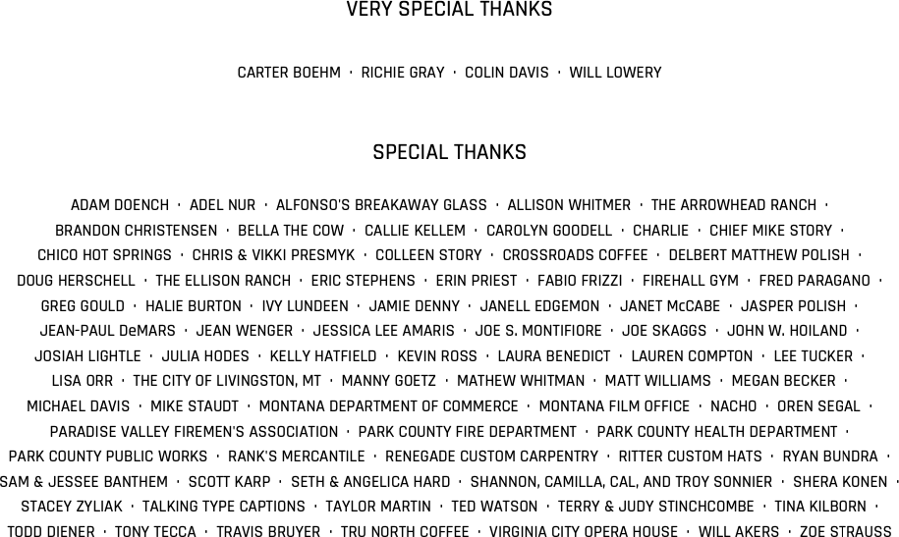

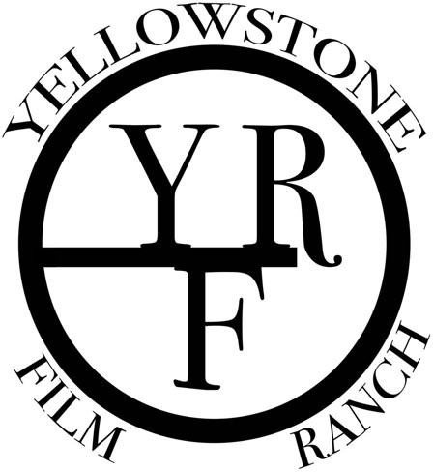

Filmed on location at Yellowstone Film Ranch, Paradise Valley, Montana

Country of Origin: United States of America

Bonfire Conviction, LLC is the author of this motion picture for the purposes of U.S. copyright law and the Berne Convention, as well as other international laws giving effect thereto.

The characters and events portrayed in this motion picture are fictitious. Any similarity to actual persons, living or dead, or to actual events is purely coincidental.

Ownership of this motion picture is protected under the laws of the United States of America and other countries. Any unauthorized duplication, distribution or exhibition of this motion picture or any part thereof (including soundtrack) could result in criminal prosecution as well as civil liability.

Copyright © 2022 Bonfire Conviction, LLC. All Rights Reserved.

